The result here is obtained by running

python compareInput.py -f "../data/fuzzyScores_0-1000.txt" -m "../data/1000annotate.csv" -p 0.5 -rt 0.97 -pt 0.9 -save "temp"

*note that the weight percentage “-p” here is set to 0.5 based on the result shown in “optimal weight” directory.

The console output:  
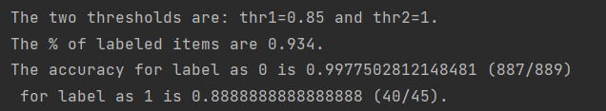

With r = 0.97 and p = 0.9 to set threshold, the thr1 = 0.85, thr2 = 1.

93.4% data are labeled as either 0 or 1.

Accuracy for label=0 is 99.78%, accuracy for label=1 is 88.89%.

The **inconsistent cases** between fuzzy matching and manual annotation:

1. For fuzzy matching label = 0:



1. For fuzzy matching label = 1:



--these are not 100 scores previously b/c of case-sensitive fuzzy matching. Now it’s case-insensitive.